

**DIGITAL REACTION TIMER**

**A MINI-PROJECT REPORT**

***Submitted By:***

***MAHATI KULKARNI(ENG18CS0155)***

***KURUVA DIVYASREE(ENG18CS0144)***

***M.NIVEDITHA(ENG18CS0151)***

***KEERTHANA(ENG18CS0130)***

***LAKSHMI POOJITHA(ENG18CS0150)***

***Of***

**BACHELOR OF TECHNOLOGY**

***in***

**DEPARTMENT OF COMPUTER SCIENCE & ENGINEERING**

***at***

**DAYANANDA SAGAR UNIVERSITY**

**SCHOOL OF ENGINEERING, BANGALORE-560068**

**3rd SEMESTER**

**(Course Code: 16CS272)**

**Digital Circuits and Logic Design Laboratory**

**DAYANANDA SAGAR UNIVERSITY**



**CERTIFICATE**

This is to certify that the Object Oriented Programming Mini-Project report entitled **“DIGITAL REACTION TIMER”** being submitted by K Divyasree, Mahati Kulkarni, M Niveditha, Lakshmi Poojitha and Keerthana B to Department of Computer Science and Engineering, School of Engineering, Dayananda Sagar University, Bangalore, for the 3rd semester B. Tech C.S.E of this university during the academic year 2019-2020.

***Date***:___________ ____________________________

***Signature of the Faculty in Charge***

____________________________

***Signature of the Chairman***

**ACKNOWLEDGEMENT**

We are pleased to acknowledge **Neeta M S, Assistant Professor,** Department of Computer Science & Engineeringfor her invaluable guidance, support, motivation and patience during the course of this mini- project work.

We extend our sincere thanks to **Dr. Banga M.K**, **Chairman,** Department of Computer Science & Engineering who continuously helped us throughout the project and without his guidance, this project would have been an uphill task.

We have received a great deal of guidance and co-operation from our friends and we wish to thank one and all that have directly or indirectly helped us in the successful completion of this mini-project work.

**Team Members**

***MAHATI KULKARNI(ENG18CS0155)***

***KURUVA DIVYASREE(ENG18CS0144)***

***M.NIVEDITHA(ENG18CS0151)***

***KEERTHANA(ENG18CS0130)***

***LAKSHMI POOJITHA(ENG18CS0150)***

Abstract

Reaction time is one of the important methods to study a person’s central information processing speed and coordinated peripheral movement response.

Reaction is a purposeful voluntary response to an external stimulus. There is certain time period between application of external stimulus and appropriate motor response to the stimulus called the reaction time. Reaction time is defined as interval of time between presentation of stimulus and appearance of appropriate voluntary response in a subject . It is usually expressed in milliseconds. It reflects the speed of the flow of neurophysiological, cognitive, and information processes which are created by the action of stimulus on the person’s sensory system. The receipt of information (visual or auditory), its processing, decision making, and giving the response or execution of the motor act are the processes which follow one another and make what we call the reaction time.

TABLE OF CONTENTS

**Chapter No.** **TITLE**   **Page No**

1. Introduction 6

1.1 Problem Statement 6

1.2 Objectives of the project 6

1. Requirements 7
2. Design Solution/Circuit Diagram 8
3. Working Principle 9
4. Screenshots of project 11
5. Conclusion 12

7. References 13

**1.INTRODUCTION**

Reaction time is a measure of the quickness an organism responds to some sort of stimulus. You also have "reflexes" too. Reflexes and reactions, while seeming similar, are quite different. Reflexes are involuntary, used to protect the body, and are faster than a reaction. Reflexes are usually a negative feedback loop and act to help return the body to its normal functioning stability, or homeostasis. The classic example of a reflex is one you have seen at your doctor's office: the patellar reflex.

* 1. **PROBLEM STATEMENT**

Reaction time plays a role in the majority of our day-to-day activities. Our ability to interact with out surroundings and react to unexpected changes and events depends directly on this cognitive skill. Being able to evaluate reaction time and understand how it functions could be very helpful in a variety of situations and areas.

Any type of disorder that is characterized by perception, information processing, or motor problems will also affect reaction time. This is why reaction time is so **sensitive to alterations**. Thus regularly trying to improve on these things is what a reaction timer allows.

**1.2 OBJECTIVES OF THE PROJECT**

Reaction speed is a crucial, if often-overlooked skill. Whatever your sport, fitness level or age, improving reaction times can have myriad benefits. This project is one such device that allows a person to clock their response time.

**2 REQUIREMENTS**

1. 555 timer IC-

It is a monolithic timing circuit that gives precise and highly stable delays of time or oscillation.

1. 4026 IC-

The 4026 is a decade counter integrated circuit (IC) with decoded outputs for driving a common-cathode seven-segment LED display.

1. 7 segment display-

A seven-segment display is a form of electronic display device for displaying decimal numerals that is an alternative to the more complex dot matrix displays.

1. Two- push ON, push OFF button-

A push button switch is a small, sealed mechanism that completes an electric circuit when you press on it. When it's on, a small metal spring inside makes contact with two wires, allowing electricity to flow. When it's off, the spring retracts, contact is interrupted, and current won't flow.

1. Resistors – 100k (2), 1k, 47k-

A resistor is a passive two-terminal electrical component that implements electrical resistance as a circuit element. In electronic circuits, resistors are used to reduce current flow.

1. Capacitor 1uF-

A capacitor is a device that stores electrical energy in an electric field. It is a passive electronic component with two terminals.

**3. CIRCUIT DESIGN**

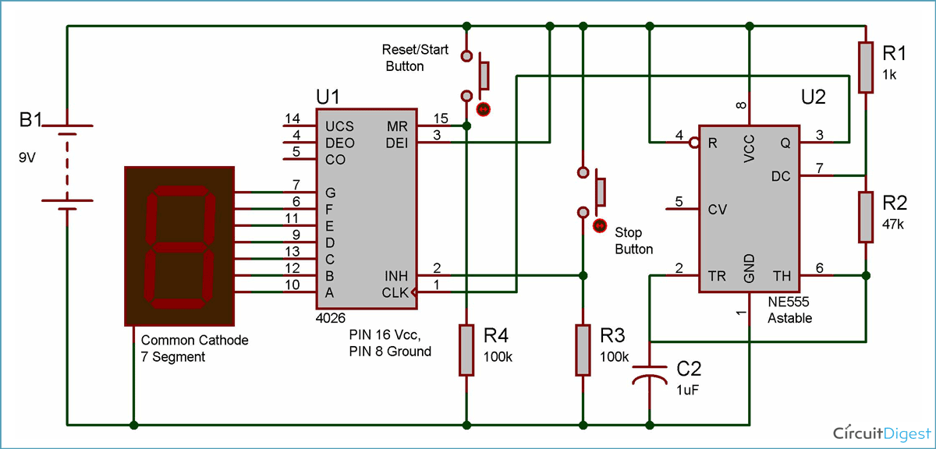

Pin 2 is used to freeze the display in 7 segment when connected to HIGH, which we have used on STOP button. Pin 15 is used to reset the IC when HIGH and seven segment displays 0, this PIN is used on START/RESET switch. Both the PIN 2 and 15 are active high pins.

PINS 6,7,9,10,11,12,13 are used to connect with the 7segemet display, we have used common cathode [seven segment display](http://circuitdigest.com/article/7-segment-display), in which cathodes, of the all LEDs inside 7 segment, are connected together.

 4026 is used to display numbers on seven segment displays and increment the number by one, when a clock pulse is applied to its PIN 1. That means more the clock pulse rate, faster the numbers change on 7 segment.

**4. WORKING PRINCIPLE**

Here we are using **4026 IC**, which is a 4000 series CMOS seven-segment counter IC. It is used to display numbers on seven segment displays and increment the number by one, when a clock pulse is applied to its PIN 1. That means more the clock pulse rate, faster the numbers change on 7 segment. Below is the pin diagram and pin description of 4026 IC.

##### ****IC 4026 Pin Diagram****

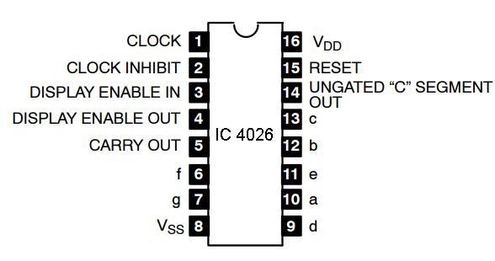

We have used common cathode [seven segment display](http://circuitdigest.com/article/7-segment-display), in which cathodes, of the all LEDs inside 7 segment, are connected together.

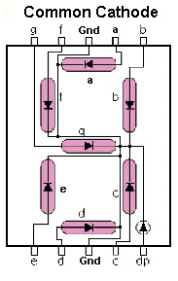

Now the main component of the circuit, [555 timer IC](http://circuitdigest.com/555-timer-circuits) comes into picture. 555 is used here to provide the CLOCK pulse to 4026 IC at PIN 1 so that numbers can be changed in 7 segment. 555 is used in Astable multivibrator mode, and the clock pulse rate can be controlled by the Resistor R1, R2 and the Capacitor.

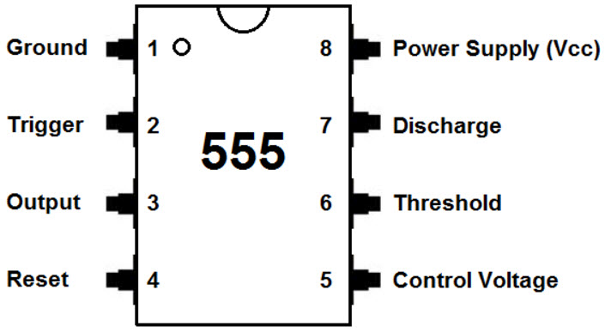

This timer is used in the pulse generation, oscillators and in different timer circuits. The 555timer produces time delays in the oscillator, also in **flip flop elements** and the 555 timer contains three modes which are Astable, Bistable and Monostable modes.

**5. SCREENSHOTS OF THE PROJECT**

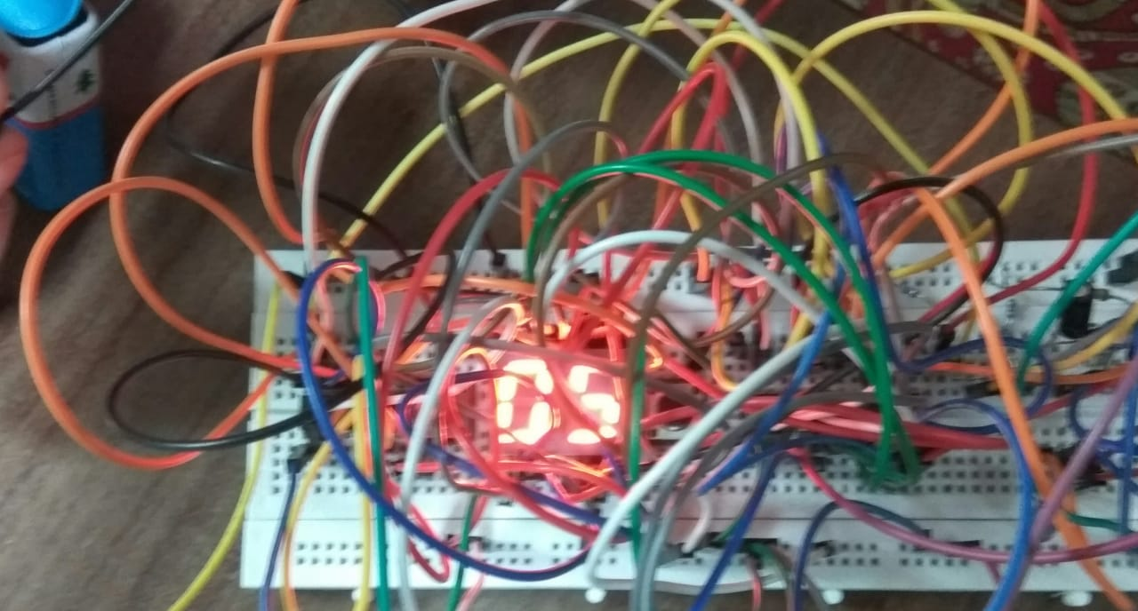

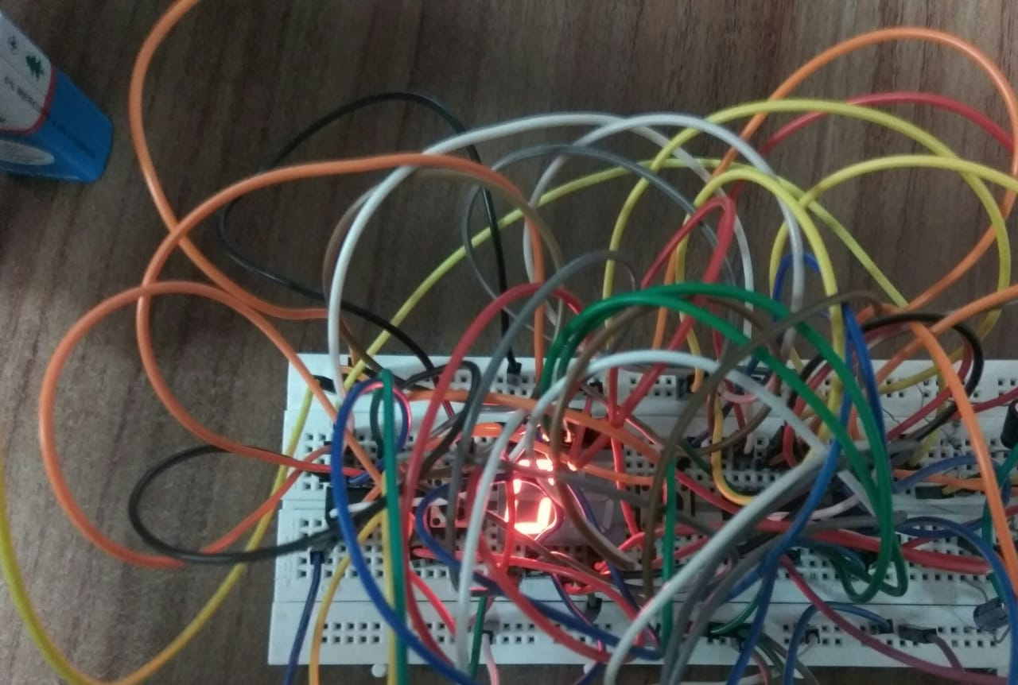

**6. CONCLUSION**

[Mental chronometry](http://en.wikipedia.org/wiki/Mental_chronometry) is the study of how fast humans react to different inputs. It takes a few hundred milliseconds for the signal to get from your eyes, to your brain, out to your limbs to respond. The reaction timer is a great project to demonstrate this time delay. It also makes for a fun game between friends!

The speed of your reactions play a large part in your everyday life. Fast reaction times can produce big rewards, for example, like saving a blistering soccer ball from entering the goal. Slow reaction times may come with consequences.

[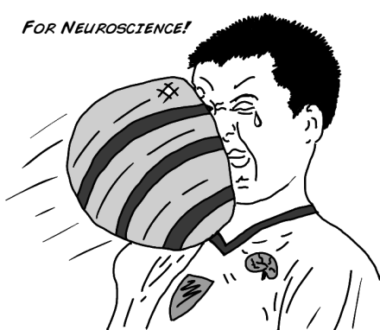](https://backyardbrains.com/experiments/img/BYB_Exp3_Pic1.png)

Thus using reaction timer you can practice and work on your reflexes and how to improve them.

1. **REFERENCE**

[1] [www.circuitdigest.com](http://www.circuitdigest.com)

[2] Google images

[3] www.electroschematics.com